**Project Documentation :-**

**Contents:**

.Project and Developer details.

.Agile Sprint. (2 weeks)

.Algorithms and Flowcharts.

.Core Concepts used.

.Git-hub Repository Link.

.Unique selling point.

* ***Project and Developer Details :-***

***Project Details :-***

The main purpose of this project is to create a prototype of the application to digitalize the products & chose LockedMe.com as first project from the ***Company Lockers Pvt. Ltd***

***Developer name :-***

***“Molly Mukherjee”***

* ***Agile Sprint :-***

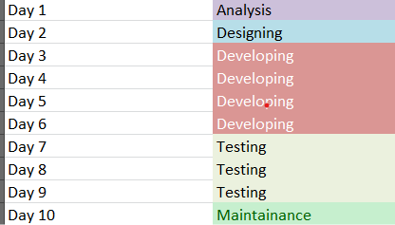

* ***Algorithms and Flowchart :-***

***Algorithm :-***

Step.1 – Creating a Scanner object in main method.

Step.2- Using While loop and displaying main menu options.

Step.3- Scanning the user input and storing it in a variable ‘m’.

Step.4- Using Switch Case Statements to execute the operations in main menu.

Step.5- Taking another while loop in the sub-menu to maintain the continuity until user chooses to move out from there.

Step.6- Using nested switch case in the sub-menu to execute add/delete/search operations. Last option is to go to the main menu from this sub-menu.

Step.7- From the main menu ,choosing Exit option to move out of the program.

***Flowchart*** :- 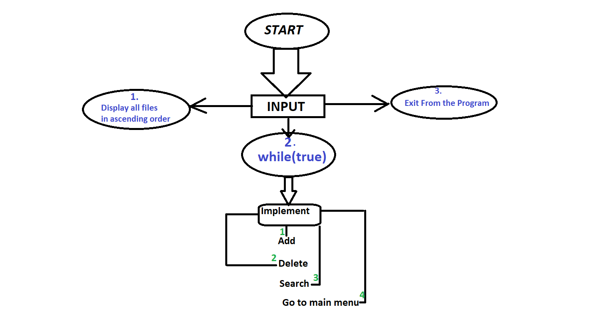

* ***Core Concepts Used :-***
  + - * Using Switch and Nested Switch Statements to check user input conditions
* Using while loops to maintain flow of program
* Using Scanner class to take user input from the given options
* Using File Operations to display all files in ascending order and to perform add/delete/search operations within the files.
* Finally using exit statement to move out from the program.
* ***Git-hub Repository link*** :-
* https://github.com/Molly-javafsd/Phase1MainProject.git
* ***Unique Selling Point :-***
* The program has 2 while loops to ensure continuity of program , unless and until User decides to Exit from the main menu..